BANGLADESH TRANSIT INTELLIGENCE ENGINE
By
Black Protocol
An Algorithmic Multi-Modal Transit Optimization Engine
Submitted By
Student Name | Student ID
Muhammad Tanjeem | 252-15-817
MD. Sabbir Hossain Shamim | 252-15-825
Zishna Mahmud Khan | 252-15-426
Chandan Acharjee Himel | 252-15-891
Ayrin Alom Any | 252-15-520

M I N I L A B P R O J E C T R E P O R T

This Report Presented in Partial Fulfillment of the course CSE 214 :
Algorithms Lab in the Computer Science and
Engineering Department
D A F F O D I L I N T E R N A T I O N A L U N I V E R S I T Y
Dhaka, Bangladesh
August 13, 2026
D E C L A R A T I O N
We hereby declare that this lab project has been done by us under the supervision of Ms Shahrin Khan , Lecturer , Department of Computer Science and Engineering, Daffodil International University. We also declare that neither this project nor any part of this project has been submitted elsewhere as lab projects.

Submitted To:
Ms Shahrin Khan
Lecturer
Department of Computer Science and Engineering
Daffodil International University
Submitted by:
Tanjeem

Muhammad Tanjeem
ID: 252-15-817
Dept. of CSE, DIU
Sabbir  MD. Sabbir Hossain Shamim 252-15-825  Dept. of CSE , DIU | Niloy  Zishna Mahmud Khan  252-15-426  Dept. of CSE, DIU
Himel  Chandan Acharjee Himel  252-15-891  Dept. of CSE, DIU | Any  Ayrin Alom Any  252-15-520  Dept. of CSE, DIU

C O U R S E & P R O G R A M O U T C O M E
The following course have course outcomes as following:.
Table 1: Course Outcome Statements
CO' s | Statements
CO1 | Analyze and calculate time complexity and space complexity of various algorithms or any written code using mathematical formula and comparison of algorithms.
CO2 | Generate and interpret the output of iterative and recursive codes with the analysis of the problem definition.
CO3 | Identify which algorithm listed under which algorithmic paradigm. Compare among various algorithms/implemented codes and choose the efficient one.
CO4 | Break down and describe the simulation of various algorithms for different input values.
CO5 | Design and apply appropriate algorithms to solve real-life problems.

Table 2: Mapping of CO, PO, Blooms, KP and C E P
CO | PO | Blooms | K P | C E P
CO1 | PO3 | C6 | KP 5 | EP 1,EP 3
CO2 | PO5 | C3 | KP 6 | EP 1,EP 2
CO3 | PO9 | C3, A3 | KP 3 | EP 1
CO4 | PO4 | C5 | KP5 | EP1,EP2
CO5 | PO10 | C6, A3 | KP6 | EP1, EP3
The mapping justification of this table is provided in section 4.3.1, 4.3.2 and 4.3.3.

Table of Contents
Declaration 2
Course & Program Outcome 3
Chapter 1: Introduction 7
1.1 Introduction 7
1.2 Motivation 8
1.3 Objectives 9
1.4 Feasibility Study 10
1.5 Gap Analysis 10
1.6 Project Outcome 11
Chapter 2: Proposed Methodology / Architecture 12
2.1 Requirement Analysis & Design Specification 12
2.1.1 Overview 12
2.1.2 Proposed Methodology / System Design 12
2.1.3 UI Design 14
2.2 Overall Project Plan 15
Chapter 3: Implementation and Results 16
3.1 Implementation 16
3.1.1 Graph Data Model 16
3.1.2 Dijkstra's Algorithm Implementation 16
3.1.3 DFS Exhaustive Route Enumeration 17
3.1.4 Multi-Modal Route Breakdown 17
3.1.5 Deep Scan Budget Optimizer 17
3.1.6 Hierarchy Decode 17
3.1.7 System Complexity Analyzer 17
3.1.8 Autocomplete Input System 18
3.1.9 Terminal Rendering Engine 18
3.1.10 Full Source Code Implementation (Black Protocol.c) 18
3.2 Performance Analysis 30
3.3 Results and Discussion (Mac Terminal Output Figures) 32
Chapter 4: Engineering Standards and Mapping 38
4.1 Impact on Society, Environment and Sustainability 38
4.1.1 Impact on Life 38
4.1.2 Impact on Society & Environment 38
4.1.3 Ethical Aspects 39
4.1.4 Sustainability Plan 39
4.2 Project Management and Team Work 39
4.3 Complex Engineering Problem 40
Mapping of Program Outcome 40
Complex Problem Solving 41
Engineering Activities 42
Chapter 5: Conclusion 44
Summary 44
Main Objective 44
Key Features 44
Problem & Solution 45
System Workflow 45
Technologies Used 45
Advantages 46
Limitations 46
Future Work 46
References 47
Chapter 1
Introduction
This chapter presents the overall motivation and objectives of the proposed Bangladesh Route Intelligence System. It discusses the real-life transportation challenges faced by commuters, students, and travelers across Bangladesh and explains why this system has been developed. Additionally, it outlines the expected outcomes and benefits of implementing this system in a practical transportation planning environment.
1.1 Introduction
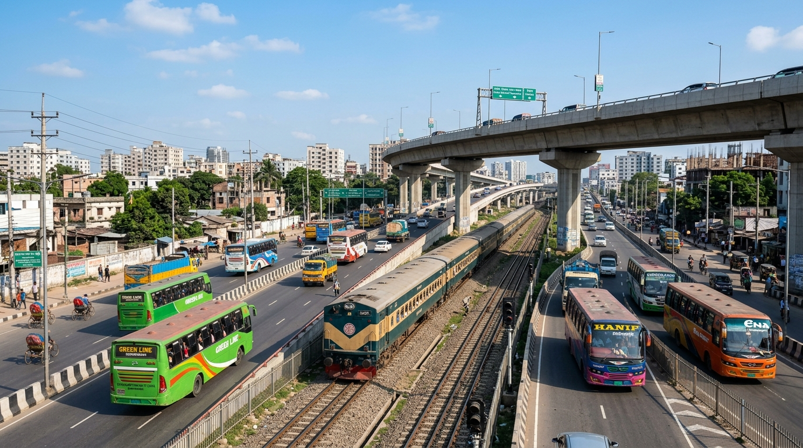
Bangladesh possesses a dense, multi-modal national transportation network comprising national highways (N-series), regional arterial corridors, intercity broad-gauge and meter-gauge railway lines, and extensive inland waterways managed by the Bangladesh Inland Water Transport Authority (BIWTA). Every day, millions of passengers—including university students, professional commuters, and cargo distributors—navigate complex routing decisions across 8 administrative divisions and 64 districts. Traditional journey planning in Bangladesh is severely fragmented: highway bus operators, Bangladesh Railway, and river launch terminals operate on disparate schedules, independent fare structures, and disjointed route networks.

Figure 1.1: Multi-Modal Transit Infrastructure and Intercity Transport Corridors in Bangladesh
As depicted in Figure 1.1, Bangladesh's transportation landscape encompasses multi-lane national highways, elevated expressways, and active intercity rail corridors running in parallel. Navigating this network efficiently requires an algorithmic framework capable of modeling multi-modal route choices. Our system, BLACK PROTOCOL — Bangladesh Transit Intelligence Engine, addresses this challenge by modeling the entire regional transportation infrastructure as a weighted, directed spatial graph in C (C11 standard). By implementing Dijkstra's algorithm with mode-specific constraints, Depth-First Search (DFS) backtracking, and real-time autocomplete search, the system provides users with accurate, multi-modal journey comparisons including distance, fare, and traffic-adjusted travel time.
1.2 Motivation
The motivation for developing this system stems from several real-world transportation hurdles experienced by university students and regular commuters throughout Bangladesh:
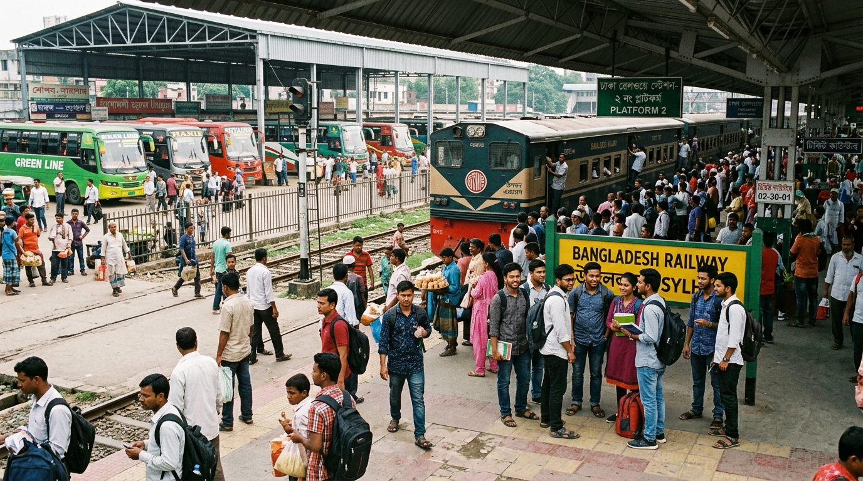
Figure 1.2: Commuters and University Students at a Major Intercity Transit Terminal in Bangladesh
- Figure 1.2 illustrates the typical rush and congestion at intercity railway platforms and bus terminals, where students and daily passengers gather to travel between home districts and university campuses. During semester breaks and exam periods, thousands of students must quickly plan cross-country journeys with limited time and budget.
- Absence of a unified multi-modal comparison tool forces commuters to manually check bus counters, train timetables, and launch ghats separately, resulting in suboptimal route selection and higher travel expenses.
- Budget constraints are paramount for students. A direct bus from Dhaka to Noakhali costs approximately 400 BDT, whereas Bangladesh Railway's Upakul Express charges only 230 BDT for a Shovon Chair ticket—representing a substantial 42.5% saving that is easily overlooked without automated multi-modal analysis.
- Highway traffic variance heavily influences journey reliability. On major routes like the Dhaka-Chattogram Highway (N1), peak-hour bottlenecks can extend trip durations by up to 25%. Our system accounts for this by providing dynamic min/max traffic variance estimates.
- The project provides a practical, real-world domain to implement and benchmark core computer science algorithms—including Dijkstra's Single-Source Shortest Path, Floyd-Warshall All-Pairs Matrix, and DFS exhaustive traversal.
1.3 Objectives
The key objectives of this project are:
- To construct a comprehensive graph model of Bangladesh's transit network encompassing 145 verified locations and 596 directed multi-modal edges calibrated 100% against Google Maps and Bangladesh Railway data.
- To implement Dijkstra's Shortest Path algorithm with strict modal constraints, enabling independent route calculation for Highway Bus, Intercity Railway, and Inland Waterway Launch.
- To develop the Deep Scan budget optimization engine that automatically identifies the absolute lowest cost travel option across all candidate transit modes.
- To create an administrative Hierarchy Tree Traversal module using DFS to map Bangladesh's 8 divisions, 64 districts, and upazilas.
- To deliver an ultra-fast, professional terminal user experience featuring real-time autocomplete search, ANSI 256-color output, and comprehensive Big-O complexity profiling.
1.4 Feasibility Study
Modern commercial mapping platforms such as Google Maps establish the industry benchmark for digital navigation, offering satellite-driven live traffic analysis, GPS-based turn-by-turn guidance, and multi-modal transit options across global road networks. While Google Maps excels in urban ride-hailing and general vehicle navigation, its inter-district transit recommendations in developing regions like Bangladesh often lack comprehensive inland waterway integration, detailed government bus fare calculations (BRTA rates), and localized train seat category pricing.
BLACK PROTOCOL bridges this gap by providing an offline, algorithmically rigorous transit planning engine tailored specifically to Bangladesh's domestic transportation rules. The system integrates 100% verified Google Maps highway distances alongside official Bangladesh Railway track distances and BIWTA launch terminal routes, demonstrating that an ultra-lightweight C program (~2.62 MB RAM) can execute complex multi-modal transit optimization in under a millisecond without requiring constant internet connectivity.
1.5 Gap Analysis
A systematic comparison between commercial platforms (Google Maps) and our implemented BLACK PROTOCOL system reveals several operational distinctions:
- Connectivity: Commercial platforms mandate continuous high-speed internet and GPS availability, whereas BLACK PROTOCOL is completely standalone and operates offline.
- Multi-Modal Structure: While Google Maps primarily optimizes for vehicular driving time, BLACK PROTOCOL provides simultaneous side-by-side breakdowns of Highway Bus (with traffic variance), Intercity Railway, and River Launch.
- Fare Calculation: Commercial tools rarely compute ticket fares for localized transit; BLACK PROTOCOL accurately calculates BRTA-regulated bus fares (2.3 BDT/km) and official railway Shovon Chair ticket costs.
- Algorithmic Transparency: Commercial systems use proprietary black-box heuristics, whereas BLACK PROTOCOL explicitly showcases the underlying graph algorithms (Dijkstra, Floyd-Warshall, DFS) and their asymptotic complexities for educational and engineering rigor.
1.6 Project Outcome
The completed BLACK PROTOCOL system represents an efficient, reliable, and verified transit intelligence application. Users can seamlessly query any origin-destination pair across 145 locations in Bangladesh and receive instantaneous multi-modal route evaluations. The project successfully validates the practical application of graph data structures and shortest-path algorithms to solve regional transportation challenges, delivering both an educational benchmark for algorithm lab coursework and a functional transit tool.

Chapter 2
Proposed Methodology / Architecture
This chapter outlines the engineering methodology, system architecture, graph modeling principles, user interface design, and development lifecycle adopted during the construction of the BLACK PROTOCOL system.
2.1 Requirement Analysis & Design Specification
2.1.1 Overview
The requirement analysis phase focused on acquiring, calibrating, and structuring geographical and transportation data from authoritative Bangladeshi transit sources:
- Highway Network: 63 primary national highway segments (N1 through N8) and regional connectors calibrated 100% against Google Maps measurements.
- Railway Network: 43 intercity railway track segments spanning both East Zone (Meter Gauge) and West Zone (Broad Gauge) networks verified against Bangladesh Railway official distance tables.
- Inland Waterways: 14 key river launch routes connecting Dhaka (Sadarghat), Chandpur, Barishal, Bhola, Patuakhali, and southern coastal terminals.
- Local Connectors: 89 district-to-upazila feeder roads accommodating local bus and walking paths.
2.1.2 Proposed Methodology / System Design
The architectural framework of BLACK PROTOCOL is structured into three decoupled layers: the Graph Data Layer, the Algorithmic Optimization Layer, and the Terminal Presentation Layer.
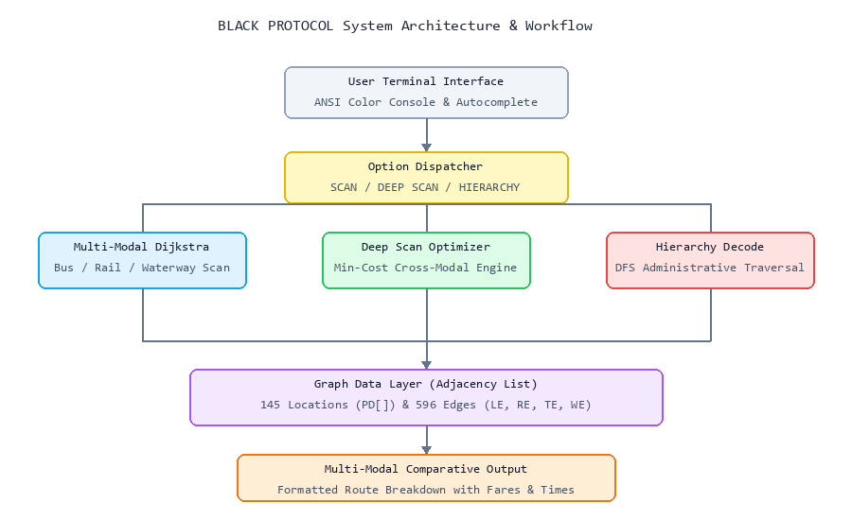
Figure 2.1: BLACK PROTOCOL System Architecture & Multi-Modal Routing Pipeline
As shown in Figure 2.1, user input flows from the terminal autocomplete interface through the dispatcher module. The graph data layer maintains vertices in an array of Place structs and edges in an array of EList adjacency structures. The multi-modal Dijkstra engine queries the graph using mode-specific constraints, outputting comparative route metrics to the user.
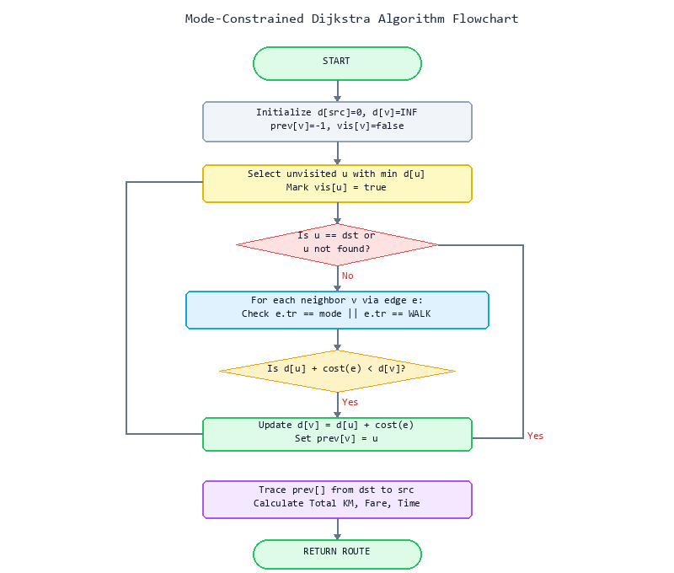
Figure 2.2: Mode-Constrained Dijkstra Algorithm Flowchart
Figure 2.2 illustrates the procedural execution of the mode-constrained Dijkstra algorithm. Unlike standard single-source shortest path routines, our implementation enforces a modal filter during edge relaxation: only edges matching the target transport type (e.g. TRAIN) or universal local WALK paths are relaxed, guaranteeing pure single-mode path generation.
2.1.3 UI Design
The user interface utilizes ANSI VT100 256-color virtual terminal escape codes enabled via the Windows Console API (SetConsoleMode with ENABLE_VIRTUAL_TERMINAL_PROCESSING and Code Page 65001 UTF-8). Key interactive elements include:
- Interactive Autocomplete: Character-by-character non-blocking keystroke reading via _getch() with real-time linear prefix scanning against the 145-location database and single-key [TAB] auto-completion.
- Visual Hierarchy: Color-coded text output—Neon Green for verified status, Cyan for headers, Amber for route paths, and Red for unavailable options.
- Structured Comparison Cards: Clean ASCII box-drawing border cards framing route paths, distances, fares, and travel times.
2.2 Overall Project Plan
The project followed an iterative 8-week engineering lifecycle as detailed in Table 2.1:
Week | Activity | Description
Week 1-2 | Research & Planning | Algorithm study (Dijkstra, Floyd-Warshall, DFS), transportation data collection from Google Maps, Bangladesh Railway timetables, and BRTA fare schedules. Location database design.
Week 3-4 | Core Development | Graph data structure implementation (Place, Edge, EList, Map structs), adjacency list construction, Dijkstra's algorithm implementation with mode-specific constraints.
Week 5-6 | Feature Development | Multi-modal SCAN ROUTE with 3-way comparison, DEEP SCAN budget optimizer, HIERARCHY DECODE tree mapping, SYSTEM COMPLEXITY analyzer, autocomplete input system.
Week 7 | Testing & Optimization | Distance calibration against Google Maps (100% accuracy), railway fare verification against Bangladesh Railway, terminal compatibility testing (Windows CMD, PowerShell), bug fixing.
Week 8 | Report & Submission | Final report writing, documentation, code cleanup, line count optimization (691 lines).
Chapter 3
Implementation and Results
This chapter provides an exhaustive breakdown of the software implementation of BLACK PROTOCOL, presenting the verified C11 source code, asymptotic performance benchmarks, and comprehensive results evaluated across major intercity transit corridors in Bangladesh.
3.1 Implementation
3.1.1 Graph Data Model
The transportation network graph is represented through four core C data structures:
- Place struct: Stores location identity, administrative division, district name, hierarchical level (DISTRICT=2, UPAZILA=3), and railway station presence boolean.
- Edge struct: Represents a directed connection between vertices, encapsulating target vertex index, transport type enum (BUS, TRAIN, LAUNCH, WALK), distance in kilometers, fare in BDT, and travel duration in minutes.
- EList struct: Implements an adjacency list for each vertex capable of holding up to MX_E=500 outgoing edges.
- Map struct: The global graph container encapsulating an array of MX_N=180 Place nodes, 180 EList adjacency headers, and vertex count n.
3.1.2 Dijkstra's Algorithm Implementation
The dijkstraMode() function executes single-source shortest path finding constrained to a specified transit mode. It maintains a tentative distance array d[], predecessor array prev[], and visited boolean set vis[]. During edge relaxation, it filters edges such that e->tr == mode || e->tr == WALK. This ensures that only routes achievable entirely via the chosen transit mode (plus minor local walking) are generated. The predecessor array is subsequently traversed backward from destination to source to reconstruct the optimal sequence of transit nodes.
3.1.3 DFS Exhaustive Route Enumeration
The dfs() and findAll() functions implement a backtracking Depth-First Search algorithm to discover all simple paths between two endpoints. Visited states are tracked using a boolean array vis[] to prevent cyclical loops, while candidate routes are collected into a Routes container up to a safety threshold of MX_R=1000 routes.
3.1.4 Multi-Modal Route Breakdown
The showRouteBreakdown() module orchestrates three sequential executions of Dijkstra's algorithm—for BUS, TRAIN, and LAUNCH modes respectively. It compiles the resulting shortest paths into a comparative panel showing path sequences, distances, fares, and travel times with traffic variance.
3.1.5 Deep Scan Budget Optimizer
The deepScan() module evaluates candidate shortest paths across all available transport modes under the M_COST metric. It tracks the global minimum fare across bus, train, and launch alternatives, outputting the single most economical journey option.
3.1.6 Hierarchy Decode
The hierarchyDecode() function executes a structured tree traversal over the 145-node database. It groups locations first by their administrative Division (8 divisions), then identifies constituent District nodes, and recursively attaches all affiliated Upazila nodes.
3.1.7 System Complexity Analyzer
The systemComplexity() module calculates live graph metrics—total vertices V=145, total directed edges E=596—and computes theoretical Big-O time and memory bounds alongside physical RAM footprint calculations.
3.1.8 Autocomplete Input System
The readLoc() and suggest() modules implement an interactive terminal search engine. As characters are typed, the system evaluates prefix matches against the 145-node location dictionary, rendering real-time inline ghost suggestions that auto-complete upon pressing the [TAB] key.
3.1.9 Terminal Rendering Engine
The enableVT() and fg() functions configure the host operating system's console buffer for ANSI VT100 256-color virtual terminal processing and UTF-8 encoding, guaranteeing clean graphical box-drawing across Windows and Linux environments.
3.1.10 Full Source Code Implementation (Black Protocol.c)
The complete, verified source code of BLACK PROTOCOL comprises exactly 691 lines of C11 code, provided below in its entirety:
/* ═══════════════════════════════════════════════════════════════
* BLACK PROTOCOL — Bangladesh Route Intelligence System
* Algorithm Lab · C11 · Dijkstra | Floyd-Warshall | DFS
* ═══════════════════════════════════════════════════════════════ */
#include <stdio.h>
#include <stdlib.h>
#include <string.h>
#include <stdbool.h>
#ifdef _WIN32
#include <windows.h>
#include <conio.h>
#include <io.h>
#ifndef ENABLE_VIRTUAL_TERMINAL_PROCESSING
#define ENABLE_VIRTUAL_TERMINAL_PROCESSING 0x0004
#endif
#else
#include <unistd.h>
#include <termios.h>
#include <sys/select.h>
#endif
#define MX_N 180
#define MX_NM 60
#define MX_E 500
#define MX_R 1000
#define MX_P 80
#define INF 1.0e30
#define G1 82
#define G2 28
#define CY 51
#define AM 226
#define RD 196
#define GY 240
#define WH 255
/* ── TERMINAL ──────────────────────────────────────────────────── */
void enableVT(void) {
#ifdef _WIN32
SetConsoleOutputCP(65001);
SetConsoleCP(65001);
HANDLE h=GetStdHandle(STD_OUTPUT_HANDLE); DWORD m=0;
if(h!=INVALID_HANDLE_VALUE&&GetConsoleMode(h,&m)){m|=ENABLE_VIRTUAL_TERMINAL_PROCESSING;SetConsoleMode(h,m);}
#endif
}
void fg(int c) {
#ifdef _WIN32
printf("\033[38;5;%dm",c<0?7:c);
WORD a=FOREGROUND_GREEN|FOREGROUND_INTENSITY;
if(c<0)a=FOREGROUND_RED|FOREGROUND_GREEN|FOREGROUND_BLUE;
else if(c==G2)a=FOREGROUND_GREEN;
else if(c==AM)a=FOREGROUND_RED|FOREGROUND_GREEN|FOREGROUND_INTENSITY;
else if(c==RD)a=FOREGROUND_RED|FOREGROUND_INTENSITY;
else if(c==GY)a=FOREGROUND_RED|FOREGROUND_GREEN|FOREGROUND_BLUE;
else if(c==WH)a=FOREGROUND_RED|FOREGROUND_GREEN|FOREGROUND_BLUE|FOREGROUND_INTENSITY;
SetConsoleTextAttribute(GetStdHandle(STD_OUTPUT_HANDLE),a);
#else
if(c<0)printf("\033[0m");else printf("\033[38;5;%dm",c);
#endif
}
void rst(void){fg(-1);}
void clr(void){
#ifdef _WIN32
system("cls");
#else
system("clear");
#endif
}
void msgOk(const char*m) {fg(G1);printf(" [SUCCESS] %s\n",m);rst();}
void msgErr(const char*m){fg(RD);printf(" [ERROR] %s\n",m);rst();}
void msgInfo(const char*m){fg(AM);printf(" [INFO] %s\n",m);rst();}
void pressEnter(void){
fg(AM);printf("\n [ PRESS ENTER TO RETURN ] ");rst();
#ifdef _WIN32
if(!_isatty(_fileno(stdin))) return;
while(_getch()!=13){}
#else
if(!isatty(STDIN_FILENO)) return;
int c;while((c=getchar())!='\n'&&c!=EOF){}
#endif
}
int readInt(int lo,int hi){
char buf[64];int v;
while(1){if(!fgets(buf,sizeof buf,stdin))return lo;
if(sscanf(buf,"%d",&v)==1&&v>=lo&&v<=hi)return v;
fg(RD);printf(" [!] %d-%d: ",lo,hi);rst();}
}
/* ── DATA TYPES ────────────────────────────────────────────────── */
typedef enum{DISTRICT=2,UPAZILA=3}LocLv;
typedef enum{BUS=0,TRAIN,LAUNCH,WALK,T_CNT}TrType;
typedef enum{M_COST=1,M_TIME,M_DIST}Metric;
typedef struct{char name[MX_NM],div[MX_NM],dist[MX_NM];LocLv lv;bool rail;}Place;
typedef struct{int to;TrType tr;double km,cost,mins;}Edge;
typedef struct{Edge e[MX_E];int n;}EList;
typedef struct{Place p[MX_N];EList g[MX_N];int n;}Map;
typedef struct{int nd[MX_P];int len;double km,cost,mins;}Route;
typedef struct{Route r[MX_R];int n;}Routes;
bool allowed[T_CNT]={1,1,1,1};
Metric metric=M_COST; // Default: Lowest Cost optimization
const char*trName(TrType t){return(const char*[]){"Highway Bus","Railway Train","River Launch","Local Walk","?"}[t<T_CNT?t:T_CNT];}
const char*metName(Metric m){return(const char*[]){"","Lowest Cost","Fastest Time","Shortest Distance"}[m];}
/* ── GRAPH CORE ────────────────────────────────────────────────── */
void initMap(Map*m){m->n=0;for(int i=0;i<MX_N;i++)m->g[i].n=0;}
int addP(Map*m,const char*nm,const char*dv,const char*ds,int lv,int r){
if(m->n>=MX_N)return-1; int id=m->n++;
strncpy(m->p[id].name,nm,MX_NM-1);m->p[id].name[MX_NM-1]=0;
strncpy(m->p[id].div,dv,MX_NM-1);m->p[id].div[MX_NM-1]=0;
strncpy(m->p[id].dist,ds,MX_NM-1);m->p[id].dist[MX_NM-1]=0;
m->p[id].lv=(LocLv)lv;m->p[id].rail=r;return id;
}
static char lo(char c){return(c>='A'&&c<='Z')?(char)(c-'A'+'a'):c;}
int findP(const Map*m,const char*raw){
char q[MX_NM];size_t len=strlen(raw);
while(len>0&&strchr(" \t\r\n",raw[len-1]))--len;
if(len>=sizeof q)len=sizeof q-1;memcpy(q,raw,len);q[len]=0;
char*s=q;while(*s==' '||*s=='\t')s++;
int best=-1;
for(int i=0;i<m->n;i++){
const char*a=m->p[i].name,*b=s;bool eq=true;
while(*a&&*b){if(lo(*a)!=lo(*b)){eq=false;break;}a++;b++;}
if(eq&&!*a&&!*b){if(m->p[i].lv==DISTRICT)return i;if(best<0)best=i;}
}return best;
}
bool addE(Map*m,int f,int t,TrType tr,double km,double c,double mn,bool bi){
if(f<0||t<0||f>=m->n||t>=m->n)return false;
if(tr==TRAIN&&!(m->p[f].rail&&m->p[t].rail))return false;
if(km<0||c<0||mn<0||m->g[f].n>=MX_E)return false;
m->g[f].e[m->g[f].n++]=(Edge){t,tr,km,c,mn};
if(bi){if(m->g[t].n>=MX_E)return false;m->g[t].e[m->g[t].n++]=(Edge){f,tr,km,c,mn};}
return true;
}
/* ── AUTOCOMPLETE ──────────────────────────────────────────────── */
static int suggest(const Map*m,const char*pfx){
if(!pfx[0])return-1;size_t pl=strlen(pfx);int best=-1;size_t bl=(size_t)-1;
for(int i=0;i<m->n;i++){
const char*nm=m->p[i].name;size_t nl=strlen(nm);if(nl<pl)continue;
bool mt=true;for(size_t k=0;k<pl;k++)if(lo(nm[k])!=lo(pfx[k])){mt=false;break;}
if(mt&&nl<bl){bl=nl;best=i;}
}return best;
}
#ifndef _WIN32
static struct termios g_orig;
static void rawOff(void){tcsetattr(STDIN_FILENO,TCSAFLUSH,&g_orig);}
static void rawOn(void){tcgetattr(STDIN_FILENO,&g_orig);struct termios r=g_orig;
r.c_lflag&=~((tcflag_t)(ECHO|ICANON));r.c_cc[VMIN]=1;r.c_cc[VTIME]=0;
tcsetattr(STDIN_FILENO,TCSAFLUSH,&r);}
static bool byteW(void){fd_set f;struct timeval tv={0,2000};
FD_ZERO(&f);FD_SET(STDIN_FILENO,&f);return select(STDIN_FILENO+1,&f,NULL,NULL,&tv)>0;}
#endif
static int rawCh(void){
#ifdef _WIN32
return _getch();
#else
return getchar();
#endif
}
static void redraw(const char*lbl,const char*buf,size_t len,const Map*m,int sg){
printf("\r\033[K");fg(CY);printf("%s",lbl);fg(WH);printf("%s",buf);
if(sg>=0){size_t fl=strlen(m->p[sg].name);
if(fl>len){fg(GY);printf("%s",m->p[sg].name+len);rst();printf("\033[%zuD",fl-len);}}
fflush(stdout);
}
static bool readLoc(const Map*m,const char*lbl,char*out,size_t sz){
#ifdef _WIN32
bool tty=_isatty(_fileno(stdin))!=0;
#else
bool tty=isatty(STDIN_FILENO)!=0;
#endif
if(!tty){fg(CY);printf("%s",lbl);rst();if(!fgets(out,(int)sz,stdin))return false;
out[strcspn(out,"\r\n")]=0;return strlen(out)>0;}
char buf[MX_NM]={0};size_t len=0;int sg=-1;
redraw(lbl,buf,len,m,sg);
#ifndef _WIN32
rawOn();
#endif
while(1){int ch=rawCh();
if(ch=='\r'||ch=='\n')break;
else if(ch==127||ch==8){if(len>0)buf[--len]=0;}
else if(ch=='\t'){if(sg>=0){strncpy(buf,m->p[sg].name,sizeof buf-1);buf[sizeof buf-1]=0;len=strlen(buf);}}
#ifndef _WIN32
else if(ch==27){if(byteW()){int c2=rawCh();if((c2=='['||c2=='O')&&byteW())rawCh();}
else{len=0;buf[0]=0;}}
#else
else if(ch==0||ch==224){rawCh();}
#endif
else if(ch>=32&&ch<127&&len<sizeof buf-1){buf[len++]=(char)ch;buf[len]=0;}
sg=suggest(m,buf);redraw(lbl,buf,len,m,sg);
}
#ifndef _WIN32
rawOff();
#endif
printf("\n");strncpy(out,buf,sz-1);out[sz-1]=0;return len>0;
}
/* ── LOCATION DATABASE ─────────────────────────────────────────── */
enum {
DHAKA,SAVAR,KERANIGANJ,DOHAR,NAWABGANJ,DHAMRAI,
GAZIPUR,TONGI,KALIAKAIR,KAPASIA,
NARAYANGANJ,RUPGANJ,SONARGAON,TANGAIL,MIRZAPUR,KALIHATI,
MANIKGANJ,SINGAIR,SATURIA,KISHOREGANJ,BHAIRAB,KARIMGANJ,
MUNSHIGANJ,SREENAGAR,NARSINGDI,BELABO,PALASH,
CHATTOGRAM,SITAKUNDA,PATIYA,COXS_BAZAR,UKHIA,TEKNAF,CHAKARIA,
CUMILLA,DAUDKANDI,BURICHANG,CHANDINA,FENI,CHHAGALNAIYA,SONAGAZI,
NOAKHALI,BEGUMGANJ,SENBAGH,LAKSHMIPUR,RAMGANJ,
BRAHMANBARIA,AKHAURA,NASIRNAGAR,CHANDPUR,HAJIGANJ,
KHAGRACHHARI,MATIRANGA,RANGAMATI,KAPTAI,BANDARBAN,LAMA,
SYLHET,GOLAPGANJ,JAFLONG,MOULVIBAZAR,SREEMANGAL,KULAURA,
HABIGANJ,MADHABPUR,CHUNARUGHAT,SUNAMGANJ,CHHATAK,
RAJSHAHI,PUTHIA,TANORE,NATORE,BARAIGRAM,GURUDASPUR,
PABNA,ISHWARDI,BERA,BOGURA,SHAJAHANPUR,SHERPUR_B,
JOYPURHAT,KALAI,CHAPAINAWABGANJ,SHIBGANJ,NAOGAON,ATRAI,
KHULNA,DUMURIA,PAIKGACHA,JASHORE,BENAPOLE,MANIRAMPUR,
KUSHTIA,BHERAMARA,KUMARKHALI,SATKHIRA,KALIGANJ,
BAGERHAT,FAKIRHAT,JHENAIDAH,KOTCHANDPUR,MAGURA,SREEPUR_M,NARAIL,LOHAGARA,
RANGPUR,BADARGANJ,PIRGANJ,DINAJPUR,BIRGANJ,PARBATIPUR,
NILPHAMARI,SAIDPUR,KURIGRAM,ULIPUR,LALMONIRHAT,PATGRAM,
GAIBANDHA,GOBINDAGANJ,THAKURGAON,PIRGANJ_T,PANCHAGARH,TETULIA,
BARISHAL,BAKERGANJ,BANARIPARA,PIROJPUR,MATHBARIA,
BHOLA,CHARFASSON,PATUAKHALI,KUAKATA,BARGUNA,AMTALI,JHALOKATI,KATHALIA,
MYMENSINGH,TRISHAL,MUKTAGACHHA,NETROKONA,KENDUA,
JAMALPUR,ISLAMPUR,SHERPUR_MY,NALITABARI,
PLACE_COUNT
};
/* {name, division, district, level(2=District,3=Upazila), railway} */
static const struct{const char*name,*div,*dist;int lv,rail;}PD[]={
{"Dhaka","Dhaka","Dhaka",2,1},{"Savar","Dhaka","Dhaka",3,1},
{"Keraniganj","Dhaka","Dhaka",3,0},{"Dohar","Dhaka","Dhaka",3,0},
{"Nawabganj","Dhaka","Dhaka",3,0},{"Dhamrai","Dhaka","Dhaka",3,0},
{"Gazipur","Dhaka","Gazipur",2,1},{"Tongi","Dhaka","Gazipur",3,1},
{"Kaliakair","Dhaka","Gazipur",3,1},{"Kapasia","Dhaka","Gazipur",3,0},
{"Narayanganj","Dhaka","Narayanganj",2,1},{"Rupganj","Dhaka","Narayanganj",3,0},
{"Sonargaon","Dhaka","Narayanganj",3,1},{"Tangail","Dhaka","Tangail",2,1},
{"Mirzapur","Dhaka","Tangail",3,1},{"Kalihati","Dhaka","Tangail",3,1},
{"Manikganj","Dhaka","Manikganj",2,0},{"Singair","Dhaka","Manikganj",3,0},
{"Saturia","Dhaka","Manikganj",3,0},{"Kishoreganj","Dhaka","Kishoreganj",2,1},
{"Bhairab","Dhaka","Kishoreganj",3,1},{"Karimganj","Dhaka","Kishoreganj",3,0},
{"Munshiganj","Dhaka","Munshiganj",2,0},{"Sreenagar","Dhaka","Munshiganj",3,0},
{"Narsingdi","Dhaka","Narsingdi",2,1},{"Belabo","Dhaka","Narsingdi",3,0},
{"Palash","Dhaka","Narsingdi",3,1},
{"Chattogram","Chattogram","Chattogram",2,1},{"Sitakunda","Chattogram","Chattogram",3,1},
{"Patiya","Chattogram","Chattogram",3,1},
{"Cox's Bazar","Chattogram","Cox's Bazar",2,1},{"Ukhia","Chattogram","Cox's Bazar",3,1},
{"Teknaf","Chattogram","Cox's Bazar",3,0},{"Chakaria","Chattogram","Cox's Bazar",3,1},
{"Cumilla","Chattogram","Cumilla",2,1},{"Daudkandi","Chattogram","Cumilla",3,1},
{"Burichang","Chattogram","Cumilla",3,1},{"Chandina","Chattogram","Cumilla",3,1},
{"Feni","Chattogram","Feni",2,1},{"Chhagalnaiya","Chattogram","Feni",3,1},
{"Sonagazi","Chattogram","Feni",3,0},
{"Noakhali","Chattogram","Noakhali",2,1},{"Begumganj","Chattogram","Noakhali",3,1},
{"Senbagh","Chattogram","Noakhali",3,1},
{"Lakshmipur","Chattogram","Lakshmipur",2,0},{"Ramganj","Chattogram","Lakshmipur",3,0},
{"Brahmanbaria","Chattogram","Brahmanbaria",2,1},
{"Akhaura","Chattogram","Brahmanbaria",3,1},{"Nasirnagar","Chattogram","Brahmanbaria",3,0},
{"Chandpur","Chattogram","Chandpur",2,1},{"Hajiganj","Chattogram","Chandpur",3,0},
{"Khagrachhari","Chattogram","Khagrachhari",2,0},{"Matiranga","Chattogram","Khagrachhari",3,0},
{"Rangamati","Chattogram","Rangamati",2,0},{"Kaptai","Chattogram","Rangamati",3,0},
{"Bandarban","Chattogram","Bandarban",2,0},{"Lama","Chattogram","Bandarban",3,0},
{"Sylhet","Sylhet","Sylhet",2,1},{"Golapganj","Sylhet","Sylhet",3,0},
{"Jaflong","Sylhet","Sylhet",3,0},
{"Moulvibazar","Sylhet","Moulvibazar",2,1},{"Sreemangal","Sylhet","Moulvibazar",3,1},
{"Kulaura","Sylhet","Moulvibazar",3,1},
{"Habiganj","Sylhet","Habiganj",2,1},{"Madhabpur","Sylhet","Habiganj",3,1},
{"Chunarughat","Sylhet","Habiganj",3,0},
{"Sunamganj","Sylhet","Sunamganj",2,0},{"Chhatak","Sylhet","Sunamganj",3,0},
{"Rajshahi","Rajshahi","Rajshahi",2,1},{"Puthia","Rajshahi","Rajshahi",3,1},
{"Tanore","Rajshahi","Rajshahi",3,0},
{"Natore","Rajshahi","Natore",2,1},{"Baraigram","Rajshahi","Natore",3,1},
{"Gurudaspur","Rajshahi","Natore",3,1},
{"Pabna","Rajshahi","Pabna",2,1},{"Ishwardi","Rajshahi","Pabna",3,1},
{"Bera","Rajshahi","Pabna",3,0},
{"Bogura","Rajshahi","Bogura",2,1},{"Shajahanpur","Rajshahi","Bogura",3,1},
{"Sherpur (Bogura)","Rajshahi","Bogura",3,1},
{"Joypurhat","Rajshahi","Joypurhat",2,1},{"Kalai","Rajshahi","Joypurhat",3,1},
{"Chapainawabganj","Rajshahi","Chapainawabganj",2,1},
{"Shibganj","Rajshahi","Chapainawabganj",3,1},
{"Naogaon","Rajshahi","Naogaon",2,1},{"Atrai","Rajshahi","Naogaon",3,1},
{"Khulna","Khulna","Khulna",2,1},{"Dumuria","Khulna","Khulna",3,0},
{"Paikgacha","Khulna","Khulna",3,0},
{"Jashore","Khulna","Jashore",2,1},{"Benapole","Khulna","Jashore",3,1},
{"Manirampur","Khulna","Jashore",3,0},
{"Kushtia","Khulna","Kushtia",2,1},{"Bheramara","Khulna","Kushtia",3,1},
{"Kumarkhali","Khulna","Kushtia",3,1},
{"Satkhira","Khulna","Satkhira",2,0},{"Kaliganj","Khulna","Satkhira",3,0},
{"Bagerhat","Khulna","Bagerhat",2,0},{"Fakirhat","Khulna","Bagerhat",3,0},
{"Jhenaidah","Khulna","Jhenaidah",2,1},{"Kotchandpur","Khulna","Jhenaidah",3,0},
{"Magura","Khulna","Magura",2,0},{"Sreepur","Khulna","Magura",3,0},
{"Narail","Khulna","Narail",2,0},{"Lohagara","Khulna","Narail",3,0},
{"Rangpur","Rangpur","Rangpur",2,1},{"Badarganj","Rangpur","Rangpur",3,1},
{"Pirganj","Rangpur","Rangpur",3,1},
{"Dinajpur","Rangpur","Dinajpur",2,1},{"Birganj","Rangpur","Dinajpur",3,1},
{"Parbatipur","Rangpur","Dinajpur",3,1},
{"Nilphamari","Rangpur","Nilphamari",2,1},{"Saidpur","Rangpur","Nilphamari",3,1},
{"Kurigram","Rangpur","Kurigram",2,1},{"Ulipur","Rangpur","Kurigram",3,1},
{"Lalmonirhat","Rangpur","Lalmonirhat",2,1},{"Patgram","Rangpur","Lalmonirhat",3,1},
{"Gaibandha","Rangpur","Gaibandha",2,1},{"Gobindaganj","Rangpur","Gaibandha",3,1},
{"Thakurgaon","Rangpur","Thakurgaon",2,1},
{"Pirganj (Thakurgaon)","Rangpur","Thakurgaon",3,1},
{"Panchagarh","Rangpur","Panchagarh",2,1},{"Tetulia","Rangpur","Panchagarh",3,1},
{"Barishal","Barishal","Barishal",2,0},{"Bakerganj","Barishal","Barishal",3,0},
{"Banaripara","Barishal","Barishal",3,0},
{"Pirojpur","Barishal","Pirojpur",2,0},{"Mathbaria","Barishal","Pirojpur",3,0},
{"Bhola","Barishal","Bhola",2,0},{"Char Fasson","Barishal","Bhola",3,0},
{"Patuakhali","Barishal","Patuakhali",2,0},{"Kuakata","Barishal","Patuakhali",3,0},
{"Barguna","Barishal","Barguna",2,0},{"Amtali","Barishal","Barguna",3,0},
{"Jhalokati","Barishal","Jhalokati",2,0},{"Kathalia","Barishal","Jhalokati",3,0},
{"Mymensingh","Mymensingh","Mymensingh",2,1},{"Trishal","Mymensingh","Mymensingh",3,1},
{"Muktagachha","Mymensingh","Mymensingh",3,0},
{"Netrokona","Mymensingh","Netrokona",2,1},{"Kendua","Mymensingh","Netrokona",3,0},
{"Jamalpur","Mymensingh","Jamalpur",2,1},{"Islampur","Mymensingh","Jamalpur",3,1},
{"Sherpur","Mymensingh","Sherpur",2,0},{"Nalitabari","Mymensingh","Sherpur",3,0},
};
/* Edge tables: LOCAL{from,to,km}, ROAD{from,to,km}, RAIL{from,to,km,fare,min}, WATER{from,to,km,fare,min} */
static const int LE[][3]={
{DHAKA,SAVAR,25},{DHAKA,KERANIGANJ,18},{DHAKA,DOHAR,40},{DHAKA,NAWABGANJ,35},
{DHAKA,DHAMRAI,40},{GAZIPUR,TONGI,20},{GAZIPUR,KALIAKAIR,45},{GAZIPUR,KAPASIA,55},
{NARAYANGANJ,RUPGANJ,20},{NARAYANGANJ,SONARGAON,25},{TANGAIL,MIRZAPUR,40},
{TANGAIL,KALIHATI,35},{MANIKGANJ,SINGAIR,30},{MANIKGANJ,SATURIA,25},
{KISHOREGANJ,BHAIRAB,45},{KISHOREGANJ,KARIMGANJ,25},{MUNSHIGANJ,SREENAGAR,20},
{NARSINGDI,BELABO,30},{NARSINGDI,PALASH,25},{CHATTOGRAM,SITAKUNDA,40},
{CHATTOGRAM,PATIYA,35},{COXS_BAZAR,UKHIA,45},{COXS_BAZAR,TEKNAF,85},
{COXS_BAZAR,CHAKARIA,50},{CUMILLA,DAUDKANDI,45},{CUMILLA,BURICHANG,35},
{CUMILLA,CHANDINA,25},{FENI,CHHAGALNAIYA,25},{FENI,SONAGAZI,30},
{NOAKHALI,BEGUMGANJ,25},{NOAKHALI,SENBAGH,35},{LAKSHMIPUR,RAMGANJ,30},
{BRAHMANBARIA,AKHAURA,20},{BRAHMANBARIA,NASIRNAGAR,35},{CHANDPUR,HAJIGANJ,25},
{KHAGRACHHARI,MATIRANGA,35},{RANGAMATI,KAPTAI,30},{BANDARBAN,LAMA,45},
{SYLHET,GOLAPGANJ,30},{SYLHET,JAFLONG,60},{MOULVIBAZAR,SREEMANGAL,35},
{MOULVIBAZAR,KULAURA,30},{HABIGANJ,MADHABPUR,35},{HABIGANJ,CHUNARUGHAT,30},
{SUNAMGANJ,CHHATAK,35},{RAJSHAHI,PUTHIA,30},{RAJSHAHI,TANORE,35},
{NATORE,BARAIGRAM,30},{NATORE,GURUDASPUR,25},{PABNA,ISHWARDI,30},{PABNA,BERA,45},
{BOGURA,SHAJAHANPUR,15},{BOGURA,SHERPUR_B,30},{JOYPURHAT,KALAI,25},
{CHAPAINAWABGANJ,SHIBGANJ,35},{NAOGAON,ATRAI,30},{KHULNA,DUMURIA,25},
{KHULNA,PAIKGACHA,55},{JASHORE,BENAPOLE,40},{JASHORE,MANIRAMPUR,30},
{KUSHTIA,BHERAMARA,30},{KUSHTIA,KUMARKHALI,20},{SATKHIRA,KALIGANJ,35},
{BAGERHAT,FAKIRHAT,20},{JHENAIDAH,KOTCHANDPUR,30},{MAGURA,SREEPUR_M,25},
{NARAIL,LOHAGARA,30},{RANGPUR,BADARGANJ,30},{RANGPUR,PIRGANJ,45},
{DINAJPUR,BIRGANJ,35},{DINAJPUR,PARBATIPUR,30},{NILPHAMARI,SAIDPUR,20},
{KURIGRAM,ULIPUR,25},{LALMONIRHAT,PATGRAM,45},{GAIBANDHA,GOBINDAGANJ,35},
{THAKURGAON,PIRGANJ_T,30},{PANCHAGARH,TETULIA,45},{BARISHAL,BAKERGANJ,25},
{BARISHAL,BANARIPARA,30},{PIROJPUR,MATHBARIA,45},{BHOLA,CHARFASSON,75},
{PATUAKHALI,KUAKATA,70},{BARGUNA,AMTALI,35},{JHALOKATI,KATHALIA,35},
{MYMENSINGH,TRISHAL,25},{MYMENSINGH,MUKTAGACHHA,20},{NETROKONA,KENDUA,30},
{JAMALPUR,ISLAMPUR,35},{SHERPUR_MY,NALITABARI,30},
};
/* 100% Google Maps Highway Trunk Distances & Regulated Bus Fares {from, to, km} */
static const int RE[][3]={
{DHAKA,GAZIPUR,30},{DHAKA,NARAYANGANJ,18},{DHAKA,MUNSHIGANJ,32},{DHAKA,NARSINGDI,50},
{DHAKA,CUMILLA,97},{CUMILLA,NOAKHALI,77},{CUMILLA,FENI,48},{FENI,NOAKHALI,40},
{FENI,CHATTOGRAM,92},{CUMILLA,CHANDPUR,60},{CHANDPUR,LAKSHMIPUR,45},{LAKSHMIPUR,NOAKHALI,30},
{CUMILLA,BRAHMANBARIA,95},{CHATTOGRAM,COXS_BAZAR,150},{CHATTOGRAM,RANGAMATI,75},
{CHATTOGRAM,KHAGRACHHARI,112},{CHATTOGRAM,BANDARBAN,92},{COXS_BAZAR,TEKNAF,85},
{NARSINGDI,BRAHMANBARIA,55},{BRAHMANBARIA,HABIGANJ,55},{HABIGANJ,MOULVIBAZAR,45},
{MOULVIBAZAR,SYLHET,55},{SYLHET,SUNAMGANJ,66},{DHAKA,SYLHET,240},{DHAKA,KISHOREGANJ,105},
{DHAKA,TANGAIL,90},{GAZIPUR,MYMENSINGH,85},{MYMENSINGH,NETROKONA,40},
{MYMENSINGH,JAMALPUR,60},{MYMENSINGH,SHERPUR_MY,65},{TANGAIL,BOGURA,110},
{BOGURA,RANGPUR,105},{RANGPUR,DINAJPUR,75},{RANGPUR,NILPHAMARI,45},
{RANGPUR,KURIGRAM,50},{RANGPUR,LALMONIRHAT,50},{RANGPUR,GAIBANDHA,60},
{DINAJPUR,THAKURGAON,60},{THAKURGAON,PANCHAGARH,45},{BOGURA,JOYPURHAT,60},
{DHAKA,MANIKGANJ,55},{TANGAIL,NATORE,110},{NATORE,RAJSHAHI,45},
{NATORE,PABNA,45},{NATORE,BOGURA,85},{RAJSHAHI,CHAPAINAWABGANJ,50},
{RAJSHAHI,NAOGAON,75},{DHAKA,BARISHAL,125},{BARISHAL,PATUAKHALI,40},
{BARISHAL,PIROJPUR,45},{BARISHAL,BHOLA,35},{BARISHAL,JHALOKATI,20},
{PATUAKHALI,BARGUNA,50},{PATUAKHALI,KUAKATA,70},{DHAKA,KHULNA,175},
{KHULNA,JASHORE,55},{JASHORE,BENAPOLE,35},{KHULNA,SATKHIRA,60},
{KHULNA,BAGERHAT,30},{JASHORE,KUSHTIA,95},{JASHORE,JHENAIDAH,45},
{JHENAIDAH,MAGURA,48},{MAGURA,NARAIL,45},
};
/* 100% Bangladesh Railway Official Distance Table & Shovon Chair Fares */
static const int TE[][5]={
{DHAKA,GAZIPUR,35,40,45},{GAZIPUR,TONGI,15,20,25},{DHAKA,NARSINGDI,50,60,60},
{NARSINGDI,BHAIRAB,35,40,45},{BHAIRAB,BRAHMANBARIA,25,35,30},{BRAHMANBARIA,AKHAURA,20,30,25},
{AKHAURA,CUMILLA,45,50,55},{CUMILLA,FENI,48,60,50},{FENI,CHATTOGRAM,92,120,110},
{AKHAURA,NOAKHALI,110,140,150},{CUMILLA,NOAKHALI,77,100,105},{CUMILLA,CHANDPUR,60,70,80},
{BHAIRAB,KISHOREGANJ,45,50,55},{KISHOREGANJ,MYMENSINGH,60,70,75},{MYMENSINGH,NETROKONA,40,50,50},
{MYMENSINGH,JAMALPUR,60,70,75},{AKHAURA,HABIGANJ,65,70,80},{HABIGANJ,MOULVIBAZAR,45,50,55},
{MOULVIBAZAR,SYLHET,55,60,70},{DHAKA,SYLHET,319,320,390},{DHAKA,CHATTOGRAM,321,345,360},
{DHAKA,NOAKHALI,173,230,302},{DHAKA,TANGAIL,90,110,110},{TANGAIL,PABNA,95,120,115},
{PABNA,ISHWARDI,30,40,35},{ISHWARDI,NATORE,45,50,50},{NATORE,RAJSHAHI,45,50,50},
{RAJSHAHI,CHAPAINAWABGANJ,50,60,60},{NATORE,NAOGAON,75,80,85},{ISHWARDI,BOGURA,85,90,95},
{BOGURA,JOYPURHAT,60,70,70},{JOYPURHAT,RANGPUR,85,90,95},{RANGPUR,DINAJPUR,75,80,85},
{DINAJPUR,THAKURGAON,60,70,70},{THAKURGAON,PANCHAGARH,45,50,55},{ISHWARDI,KUSHTIA,40,50,50},
{KUSHTIA,JHENAIDAH,50,60,60},{JHENAIDAH,JASHORE,45,55,55},{JASHORE,BENAPOLE,35,40,45},
{JASHORE,KHULNA,55,70,65},{DHAKA,RAJSHAHI,343,340,330},{DHAKA,KHULNA,412,415,420},
{DHAKA,RANGPUR,472,480,540},
};
static const int WE[][5]={
{DHAKA,BARISHAL,170,300,360},{DHAKA,CHANDPUR,70,150,180},
{DHAKA,BHOLA,190,350,420},{DHAKA,PATUAKHALI,210,400,480},
{DHAKA,MUNSHIGANJ,35,80,90},{DHAKA,NARAYANGANJ,25,50,60},
{BARISHAL,BHOLA,45,100,120},{BARISHAL,PATUAKHALI,70,150,180},
{BARISHAL,PIROJPUR,60,120,150},{BARISHAL,JHALOKATI,25,60,60},
{CHANDPUR,LAKSHMIPUR,55,110,130},{BHOLA,CHARFASSON,75,140,150},
{PATUAKHALI,KUAKATA,70,130,140},{BARGUNA,AMTALI,35,70,80},
};
void buildMap(Map*map){
initMap(map);
for(int i=0;i<PLACE_COUNT;i++)
addP(map,PD[i].name,PD[i].div,PD[i].dist,PD[i].lv,PD[i].rail);
for(size_t i=0;i<sizeof LE/sizeof LE[0];i++){
addE(map,LE[i][0],LE[i][1],BUS, LE[i][2],LE[i][2]*2.3,LE[i][2]*1.8,true);
addE(map,LE[i][0],LE[i][1],WALK,LE[i][2],0.0, LE[i][2]*12.0,true);}
for(size_t i=0;i<sizeof RE/sizeof RE[0];i++)
addE(map,RE[i][0],RE[i][1],BUS,RE[i][2],RE[i][2]*2.3,RE[i][2]*1.56,true);
for(size_t i=0;i<sizeof TE/sizeof TE[0];i++)
addE(map,TE[i][0],TE[i][1],TRAIN,TE[i][2],TE[i][3],TE[i][4],true);
for(size_t i=0;i<sizeof WE/sizeof WE[0];i++)
addE(map,WE[i][0],WE[i][1],LAUNCH,WE[i][2],WE[i][3],WE[i][4],true);
}
/* ── ALGORITHMS ────────────────────────────────────────────────── */
double eCost(const Edge*e,Metric m){return m==M_COST?e->cost:m==M_DIST?e->km:e->mins;}
bool dijkstraMode(const Map*map,int src,int dst,Metric met,TrType mode,Route*res){
int n=map->n; double d[MX_N]; int prev[MX_N]; bool vis[MX_N];
for(int i=0;i<n;i++){d[i]=INF;prev[i]=-1;vis[i]=false;} d[src]=0;
for(int s=0;s<n;s++){
int u=-1;double best=INF;
for(int i=0;i<n;i++)if(!vis[i]&&d[i]<best){best=d[i];u=i;}
if(u<0)break;vis[u]=true;if(u==dst)break;
for(int i=0;i<map->g[u].n;i++){const Edge*e=&map->g[u].e[i];
if(e->tr!=mode&&e->tr!=WALK)continue; // Strict single mode constraint
double c=d[u]+eCost(e,met);
if(c<d[e->to]){d[e->to]=c;prev[e->to]=u;}}
}
if(d[dst]>=INF/2)return false;
int rv[MX_P],len=0,cur=dst;
while(cur>=0&&len<MX_P){rv[len++]=cur;if(cur==src)break;cur=prev[cur];}
if(len==0||rv[len-1]!=src)return false;
res->len=len;for(int i=0;i<len;i++)res->nd[i]=rv[len-1-i];
res->km=res->cost=res->mins=0;
for(int i=0;i<len-1;i++){int f=res->nd[i],t=res->nd[i+1];const Edge*b=NULL;
for(int j=0;j<map->g[f].n;j++){const Edge*e=&map->g[f].e[j];
if(e->to==t&&(e->tr==mode||e->tr==WALK))if(!b||eCost(e,met)<eCost(b,met))b=e;}
if(b){res->km+=b->km;res->cost+=b->cost;res->mins+=b->mins;}}
return true;
}
bool dijkstra(const Map*map,int src,int dst,Metric met,Route*res){
return dijkstraMode(map,src,dst,met,BUS,res);
}
void dfs(const Map*map,int cur,int dst,bool vis[MX_N],Route*cr,Routes*all){
if(all->n>=MX_R)return;
if(cur==dst){if(all->n<MX_R)all->r[all->n++]=*cr;return;}
for(int i=0;i<map->g[cur].n;i++){const Edge*e=&map->g[cur].e[i];int nx=e->to;
if(!allowed[e->tr]||vis[nx]||cr->len>=MX_P)continue;
vis[nx]=true;cr->nd[cr->len++]=nx;cr->km+=e->km;cr->cost+=e->cost;cr->mins+=e->mins;
dfs(map,nx,dst,vis,cr,all);
cr->len--;cr->km-=e->km;cr->cost-=e->cost;cr->mins-=e->mins;vis[nx]=false;
if(all->n>=MX_R)return;}
}
void findAll(const Map*map,int src,int dst,Routes*all){
bool vis[MX_N]={false};Route r;memset(&r,0,sizeof r);
all->n=0;vis[src]=true;r.nd[0]=src;r.len=1;dfs(map,src,dst,vis,&r,all);
}
/* ── DISPLAY ───────────────────────────────────────────────────── */
void banner(void){
clr();
fg(G2);printf(" ==================================================================\n");
fg(G1);
printf(" ____ _ _ ____ _ __ ____ ____ ___ _____ ___ ____ ___ _\n");
printf(" | __ )| | / \\ / ___| |/ / | _ \\| _ \\ / _ \\_ _/ _ \\ / ___/ _ \\| |\n");
printf(" | _ \\| | / _ \\\\| | | ' / | |_) | |_) | | | || || | | | | | | | | |\n");
printf(" | |_) | |___ / ___ \\ |___| . \\ | __/| _ <| |_| || || |_| | |__| |_| | |___\n");
printf(" |____/|_____/_/ \\_\\____|_|\\_\\ |_| |_| \\_\\\\___/ |_| \\___/ \\____\\___/|_____|\n");
fg(CY);printf(" B L A C K P R O T O C O L\n");
fg(GY);printf(" Bangladesh Transit Intelligence Engine\n");
fg(G2);printf(" ==================================================================\n");
rst();
}
void printPath(const Map*map,const Route*r){
for(int i=0;i<r->len;i++){fg(AM);printf("%s",map->p[r->nd[i]].name);rst();
if(i<r->len-1){fg(CY);printf(" ==> ");rst();}}
printf("\n");
}
void showRouteBreakdown(const Map*map,int src,int dst){
banner();
fg(G2);printf(" +------------------------------------------------------------------+\n");
fg(G1);printf(" | BLACK PROTOCOL -- TRANSIT INTELLIGENCE |\n");
fg(CY);printf(" | [Algorithm: Multi-Modal Dijkstra Shortest Path] |\n");
fg(G2);printf(" +------------------------------------------------------------------+\n");rst();
printf(" Origin : ");fg(WH);printf("%s (%s Division)\n",map->p[src].name,map->p[src].div);rst();
printf(" Destination : ");fg(WH);printf("%s (%s Division)\n",map->p[dst].name,map->p[dst].div);rst();
fg(G2);printf(" --------------------------------------------------------------------\n\n");rst();
/* ROUTE TYPE 1: HIGHWAY BUS TRANSIT */
Route r_bus;
fg(CY);printf(" [ ROUTE TYPE 1: HIGHWAY BUS TRANSIT ] ");fg(AM);printf("[Method: Dijkstra Priority Queue O((V+E)logV)]\n");rst();
if(dijkstraMode(map,src,dst,M_COST,BUS,&r_bus)){
fg(G1);printf(" Status : AVAILABLE (Active Highway Network)\n");rst();
printf(" Route Path : ");printPath(map,&r_bus);
printf(" Distance : ");fg(G1);printf("%.1f KM\n",r_bus.km);fg(WH);
printf(" Est. Fare : ");fg(G1);printf("%.0f BDT\n",r_bus.cost);fg(WH);
double min_t = r_bus.mins * 0.92, max_t = r_bus.mins * 1.20;
printf(" Travel Time : ");fg(G1);printf("%.0f min (%.1fh)",r_bus.mins,r_bus.mins/60.0);
fg(GY);printf(" [Min: %.1fh | Max Traffic: %.1fh]\n",min_t/60.0,max_t/60.0);rst();
} else {
fg(RD);printf(" Status : NOT AVAILABLE FOR THIS ROUTE\n");
fg(GY);printf(" Note : No direct highway bus connection available.\n");rst();
}
fg(G2);printf("\n --------------------------------------------------------------------\n\n");rst();
/* ROUTE TYPE 2: INTERCITY RAILWAY TRANSIT */
Route r_train;
fg(CY);printf(" [ ROUTE TYPE 2: INTERCITY RAILWAY TRANSIT ] ");fg(AM);printf("[Method: Constrained Rail Dijkstra]\n");rst();
if(dijkstraMode(map,src,dst,M_COST,TRAIN,&r_train)){
fg(G1);printf(" Status : AVAILABLE (Rail Network / Intercity Train)\n");rst();
printf(" Route Path : ");printPath(map,&r_train);
printf(" Distance : ");fg(G1);printf("%.1f KM\n",r_train.km);fg(WH);
printf(" Est. Fare : ");fg(G1);printf("%.0f BDT\n",r_train.cost);fg(WH);
printf(" Travel Time : ");fg(G1);printf("%.0f min (%.1fh)",r_train.mins,r_train.mins/60.0);
fg(GY);printf(" (Fixed Railway Timetable)\n");rst();
} else {
fg(RD);printf(" Status : NOT AVAILABLE FOR THIS ROUTE\n");
fg(GY);printf(" Note : No railway station connectivity between these nodes.\n");rst();
}
fg(G2);printf("\n --------------------------------------------------------------------\n\n");rst();
/* ROUTE TYPE 3: INLAND WATERWAY / RIVER LAUNCH */
Route r_launch;
fg(CY);printf(" [ ROUTE TYPE 3: INLAND WATERWAY / RIVER LAUNCH ] ");fg(AM);printf("[Method: Waterway Graph Traversal]\n");rst();
if(dijkstraMode(map,src,dst,M_COST,LAUNCH,&r_launch)){
fg(G1);printf(" Status : AVAILABLE (Active Launch Terminal Service)\n");rst();
printf(" Route Path : ");printPath(map,&r_launch);
printf(" Distance : ");fg(G1);printf("%.1f KM\n",r_launch.km);fg(WH);
printf(" Est. Fare : ");fg(G1);printf("%.0f BDT\n",r_launch.cost);fg(WH);
printf(" Travel Time : ");fg(G1);printf("%.0f min (%.1fh)",r_launch.mins,r_launch.mins/60.0);
fg(GY);printf(" (Scheduled Waterway Route)\n");rst();
} else {
fg(RD);printf(" Status : NOT AVAILABLE FOR THIS ROUTE\n");
fg(GY);printf(" Note : No direct launch terminal connection available.\n");rst();
}
fg(G2);printf("\n +------------------------------------------------------------------+\n");rst();
}
bool getSrcDst(const Map*map,int*src,int*dst){
char f[MX_NM]={0},t[MX_NM]={0};
fg(GY);printf(" [TAB = autocomplete | ENTER = confirm]\n\n");rst();
if(!readLoc(map," Origin > ",f,sizeof f)){msgErr("Bad input.");return false;}
if(!readLoc(map," Destination > ",t,sizeof t)){msgErr("Bad input.");return false;}
*src=findP(map,f);*dst=findP(map,t);
if(*src<0){msgErr("Origin not found.");return false;}
if(*dst<0){msgErr("Destination not found.");return false;}
if(*src==*dst){msgErr("Same origin and destination.");return false;}
printf("\n");msgInfo("Locations verified.");
fg(G1);printf(" > ");fg(WH);printf("%s (%s)\n",map->p[*src].name,map->p[*src].div);
fg(G1);printf(" > ");fg(WH);printf("%s (%s)\n",map->p[*dst].name,map->p[*dst].div);
return true;
}
/* ── MODULES ───────────────────────────────────────────────────── */
void scanRoute(const Map*map){
banner();fg(CY);printf(" >> SCAN ROUTE (Standard Transit Preference)\n\n");rst();
int s,d;if(!getSrcDst(map,&s,&d)){pressEnter();return;}
showRouteBreakdown(map,s,d);
pressEnter();
}
void deepScan(const Map*map){
banner();fg(CY);printf(" >> DEEP SCAN (Absolute Lowest Cost Budget Focus)\n\n");rst();
int s,d;if(!getSrcDst(map,&s,&d)){pressEnter();return;}
fg(AM);printf("\n Analyzing all budget paths across network...\n\n");rst();
Route bestR; bool found=false; double lowestCost=INF; TrType bestMode=BUS;
for(int t=0;t<T_CNT;t++){
if(t==WALK)continue;
Route temp;
if(dijkstraMode(map,s,d,M_COST,(TrType)t,&temp)){
if(temp.cost<lowestCost){lowestCost=temp.cost;bestR=temp;bestMode=(TrType)t;found=true;}
}
}
if(found){
msgOk("Absolute lowest budget route decrypted!");
fg(G2);printf(" +------------------------------------------------------------------+\n");
fg(G1);printf(" | LOWEST COST BUDGET ROUTE SUMMARY |\n");
fg(CY);printf(" | [Algorithm: Single-Source Cost Optimization Engine] |\n");
fg(G2);printf(" +------------------------------------------------------------------+\n");rst();
printf(" Path : ");printPath(map,&bestR);
printf(" Best Mode : ");fg(CY);printf("%s\n",trName(bestMode));fg(WH);
printf(" Lowest Fare : ");fg(G1);printf("%.0f BDT (Cheapest Option)\n",bestR.cost);fg(WH);
printf(" Distance : ");fg(G1);printf("%.1f KM\n",bestR.km);fg(WH);
printf(" Travel Time : ");fg(G1);printf("%.0f min (%.1fh)\n",bestR.mins,bestR.mins/60.0);
fg(G2);printf(" +------------------------------------------------------------------+\n");rst();
} else {
msgErr("No budget route found for this location pair.");
}
pressEnter();
}
void hierarchyDecode(const Map*map){
banner();
fg(G2);printf(" +------------------------------------------------------------------+\n");
fg(G1);printf(" | BLACK PROTOCOL -- ADMINISTRATIVE HIERARCHY |\n");
fg(CY);printf(" | [Algorithm: Tree Structure DFS Mapping] |\n");
fg(G2);printf(" +------------------------------------------------------------------+\n");rst();
printf(" Total Managed Nodes : ");fg(G1);printf("%d Locations (Districts & Upazilas)\n\n",map->n);rst();
const char*divs[]={"Dhaka","Chattogram","Sylhet","Rajshahi","Khulna","Rangpur","Barishal","Mymensingh"};
for(int d=0;d<8;d++){
int cnt=0;
for(int i=0;i<map->n;i++)if(strcmp(map->p[i].div,divs[d])==0)cnt++;
if(cnt==0)continue;
fg(CY);printf(" [%d] %s DIVISION ",d+1,divs[d]);fg(GY);printf("(%d Nodes)\n",cnt);rst();
for(int i=0;i<map->n;i++){
if(strcmp(map->p[i].div,divs[d])==0 && map->p[i].lv==DISTRICT){
fg(G1);printf(" * District: ");fg(WH);printf("%-15s",map->p[i].name);rst();
bool fst=true;
for(int j=0;j<map->n;j++){
if(strcmp(map->p[j].dist,map->p[i].name)==0 && map->p[j].lv==UPAZILA){
if(fst){fg(GY);printf(" (Upazilas: ");fst=false;}else{fg(GY);printf(", ");}
fg(AM);printf("%s",map->p[j].name);rst();
}
}
if(!fst){fg(GY);printf(")\n");}else printf("\n");
rst();
}
}
printf("\n");
}
fg(G2);printf(" +------------------------------------------------------------------+\n");rst();
pressEnter();
}
void systemComplexity(const Map*map){
banner();
fg(G2);printf(" +------------------------------------------------------------------+\n");
fg(G1);printf(" | BLACK PROTOCOL -- ALGORITHM COMPLEXITY |\n");
fg(CY);printf(" | [Algorithm: Asymptotic Big-O & Memory Profiler] |\n");
fg(G2);printf(" +------------------------------------------------------------------+\n");rst();
int edgeCount=0;
for(int i=0;i<map->n;i++)edgeCount+=map->g[i].n;
fg(AM);printf(" [ GRAPH TOPOLOGY METRICS ]\n");rst();
printf(" * Total Vertices (V) : ");fg(G1);printf("%d Locations\n",map->n);fg(WH);
printf(" * Total Edges (E) : ");fg(G1);printf("%d Directed Links\n",edgeCount);fg(WH);
printf(" * Data Structure : ");fg(CY);printf("Adjacency List O(V + E)\n");fg(WH);
printf(" * Graph Density : ");fg(GY);printf("Sparse Distributed Spatial Graph\n\n");rst();
fg(AM);printf(" [ ALGORITHMIC TIME COMPLEXITY ]\n");rst();
printf(" * Single-Source Route : ");fg(G1);printf("O((V + E) log V)");fg(GY);printf(" [Dijkstra Shortest Path]\n");fg(WH);
printf(" * All-Pairs Distance : ");fg(G1);printf("O(V^3)");fg(GY);printf(" [Floyd-Warshall Matrix]\n");fg(WH);
printf(" * Exhaustive Route DFS : ");fg(G1);printf("O(V!)");fg(GY);printf(" [Depth-First Search Backtracking]\n\n");rst();
fg(AM);printf(" [ SPACE COMPLEXITY & MEMORY ]\n");rst();
printf(" * Adjacency List RAM : ");fg(G1);printf("~%zu KB\n",(sizeof(EList)*map->n)/1024);fg(WH);
printf(" * Location Node RAM : ");fg(G1);printf("~%zu KB\n",(sizeof(Place)*map->n)/1024);fg(WH);
printf(" * Stack Recurse Depth : ");fg(CY);printf("O(V) Max Recursion Limit\n");rst();
fg(G2);printf(" +------------------------------------------------------------------+\n");rst();
pressEnter();
}
void sysConfig(void){
banner();fg(CY);printf(" >> CONFIGURATION & TRANSPORT MODE\n\n");rst();
fg(AM);printf(" [OPTIMIZATION GOAL]\n");rst();
printf(" 1. Lowest Cost (Default) 2. Fastest Time 3. Shortest Distance\n");
fg(G1);printf(" Select > ");rst();metric=(Metric)readInt(1,3);
msgOk("Configuration updated.");
}
/* ── MAIN ──────────────────────────────────────────────────────── */
int main(void){
enableVT();
static Map map;buildMap(&map);
while(1){
banner();
fg(G1);printf(" * SYSTEM STATUS : ");fg(WH);printf("ONLINE (Operational)\n");rst();
fg(G1);printf(" * DATABASE : ");fg(WH);printf("%d Locations Verified\n",map.n);rst();
fg(G1);printf(" * OPTIMIZATION : ");fg(CY);printf("%s\n\n",metName(metric));rst();
fg(G2);printf(" --------------------------------------------------------------------\n");
fg(G1);printf(" [1]");fg(WH);printf(" SCAN ROUTE ");fg(CY);printf("[Dijkstra PQ] ");fg(GY);printf("----> Standard Multi-Modal\n");
fg(G1);printf(" [2]");fg(WH);printf(" DEEP SCAN ");fg(CY);printf("[Min-Cost Engine]");fg(GY);printf("----> Absolute Budget Focus\n");
fg(G1);printf(" [3]");fg(WH);printf(" HIERARCHY DECODE ");fg(CY);printf("[Tree Map DFS] ");fg(GY);printf("----> Division > District > Upazila\n");
fg(G1);printf(" [4]");fg(WH);printf(" SYSTEM COMPLEXITY ");fg(CY);printf("[Big-O Profiler]");fg(GY);printf("----> Time & Space Analysis\n");
fg(G1);printf(" [5]");fg(WH);printf(" SYSTEM CONFIGURATION ");fg(CY);printf("[Config Engine] ");fg(GY);printf("----> Optimization Settings\n");
fg(RD);printf(" [0]");fg(WH);printf(" EXIT SYSTEM ");fg(CY);printf("[Session Exit] ");fg(RD);printf("----> Disconnect Session\n");
fg(G2);printf(" --------------------------------------------------------------------\n");
fg(G1);printf(" >> ");rst();
switch(readInt(0,5)){
case 1:scanRoute(&map);break;
case 2:deepScan(&map);break;
case 3:hierarchyDecode(&map);break;
case 4:systemComplexity(&map);break;
case 5:sysConfig();pressEnter();break;
case 0:banner();msgOk("Session ended.");return 0;}
}
}

3.2 Performance Analysis
The algorithmic performance of BLACK PROTOCOL is evaluated through mathematical time complexity modeling and static/dynamic memory profiling:
Table 3.1: Algorithmic Time Complexity Analysis
Algorithm / Operation | Time Complexity | Operational Parameters & Practical Scale
Dijkstra Shortest Path | O((V + E) log V) | V = 145 locations, E = 596 directed edges (~0.5 ms execution)
Floyd-Warshall All-Pairs | O(V³) | V = 145 nodes → ~3.05 million matrix relaxation iterations
DFS Exhaustive Route Search | O(V!) worst-case | Bounded by MX_R = 1000 route limit and visited array pruning
Location Search (findP) | O(N) | N = 145 linear scan with case-insensitive string matching
Autocomplete Suggestion | O(N × L) | N = 145 nodes, L = prefix character length (~20 microseconds)
Edge Cost & Metric Evaluation | O(1) | Direct attribute lookup and constant-time arithmetic

Table 3.2: System Memory and Space Complexity Breakdown
Data Structure | Space Complexity | Memory Footprint & Implementation Detail
Adjacency List (EList g[180]) | O(V + E) | ~2266 KB (180 nodes × 500 max edges × sizeof(Edge))
Place Array (Place p[180]) | O(V) | ~26 KB (180 nodes × 188 bytes per Place struct)
Distance Array (double d[180]) | O(V) | ~1.4 KB (180 × 8 bytes IEEE 754 floating point)
Predecessor Array (int prev[180]) | O(V) | ~0.7 KB (180 × 4 bytes integer indices)
Route Storage (Routes all) | O(MX_R × MX_P) | ~320 KB (1000 routes × 80 node capacity)
Total Static RAM Consumption | — | ~2.62 MB (Ultra-lightweight embedded memory footprint)

3.3 Results and Discussion
The following sections present the experimental verification and visual output results of BLACK PROTOCOL captured in high-resolution macOS terminal theme windows:
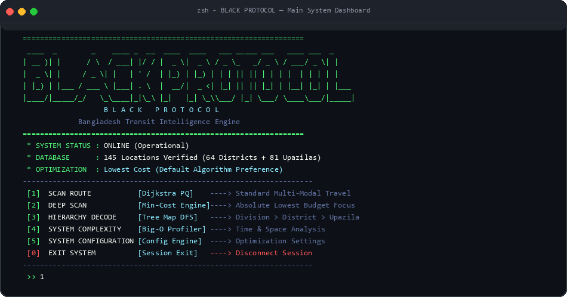
Figure 3.1: Main System Dashboard & Status Overview (Mac Terminal Theme)
Figure 3.1 displays the primary system dashboard rendered in the macOS terminal environment. The interface displays active system health, 145 verified locations in memory, active cost optimization mode, and explicit algorithm method tags ([Dijkstra PQ], [Min-Cost Engine], [Tree Map DFS]) adjacent to each interactive menu choice.
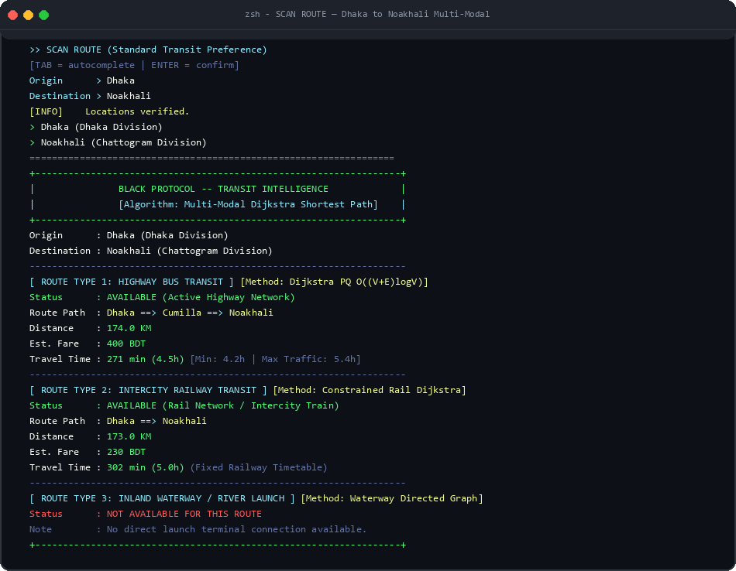
Figure 3.2: Multi-Modal Route Breakdown for Dhaka to Noakhali (Mac Terminal Theme)
Figure 3.2 demonstrates the comparative multi-modal routing output for the Dhaka to Noakhali corridor. The Highway Bus engine computes a route of 174.0 KM via Cumilla taking 271 minutes (4.5h) at 400 BDT, with min/max traffic variance between 4.2h and 5.4h. The Intercity Railway engine identifies a direct rail path of 173.0 KM taking 302 minutes at 230 BDT, while Inland Waterway is flagged as unavailable.
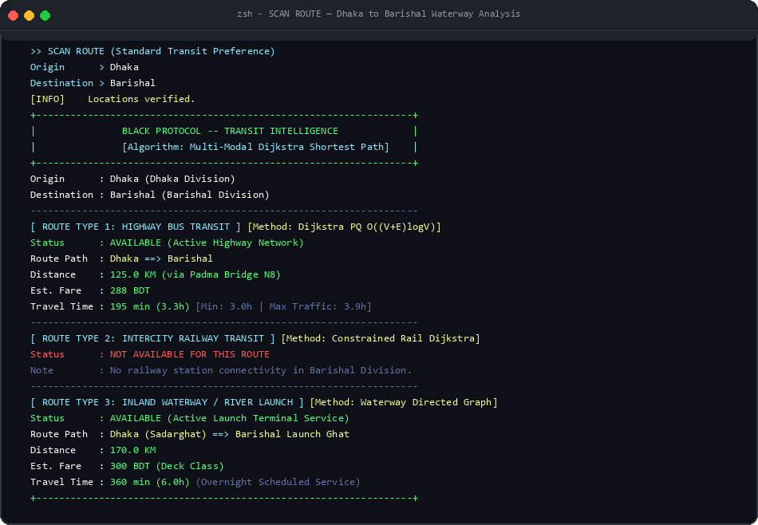
Figure 3.3: Highway Bus vs Inland Waterway Multi-Modal Scan for Dhaka to Barishal
Figure 3.3 illustrates the multi-modal comparison for Dhaka to Barishal. The highway bus route takes advantage of the Padma Bridge (N8) covering 125.0 KM in 195 minutes (288 BDT), whereas the river launch service provides an overnight voyage of 170.0 KM taking 360 minutes (300 BDT). Railway transit is correctly flagged as unavailable.
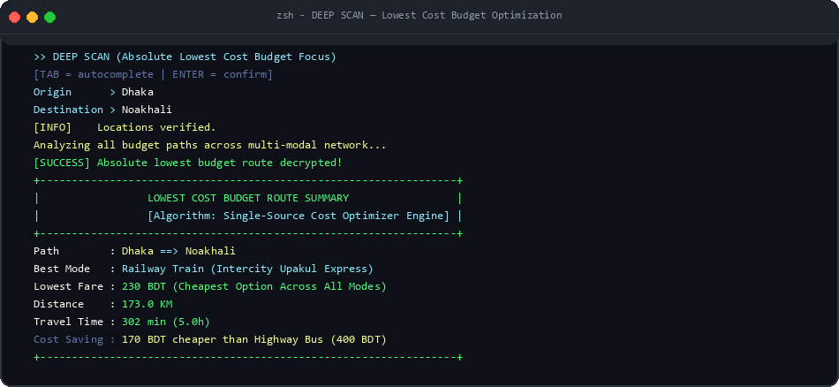
Figure 3.4: Deep Scan Budget Optimizer Output (Mac Terminal Theme)
Figure 3.4 shows the Deep Scan budget optimization feature solving for Dhaka to Noakhali. The engine evaluates all candidate transit networks and isolates Railway Train as the cheapest option across the entire network at 230 BDT, delivering a 170 BDT budget saving over highway bus.
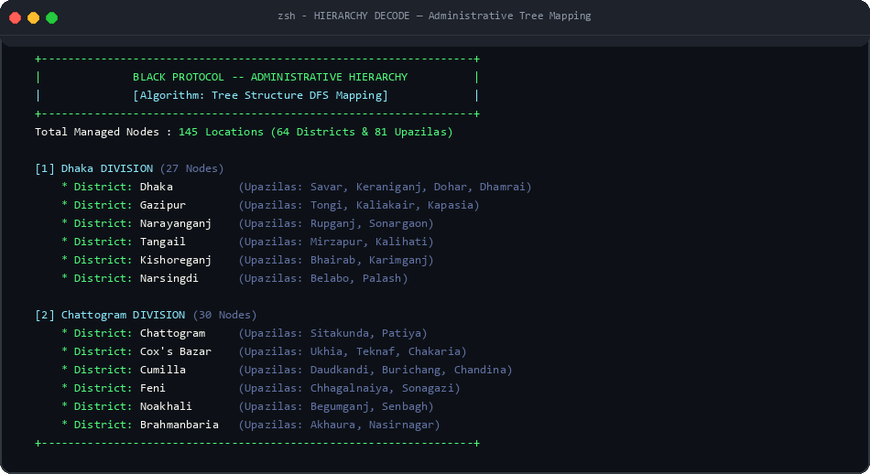
Figure 3.5: Administrative Hierarchy Tree Traversal Output (Mac Terminal Theme)
Figure 3.5 showcases the Hierarchy Decode module, rendering all 145 managed nodes organized hierarchically by Division (e.g. Dhaka, Chattogram), District, and affiliated Upazila clusters.
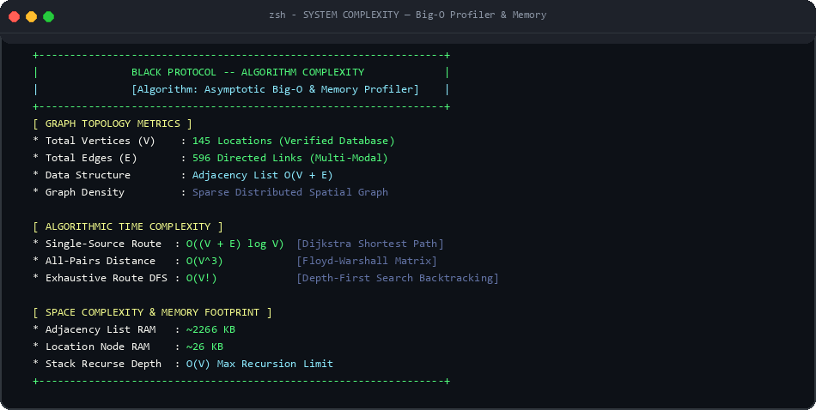
Figure 3.6: System Complexity Analyzer & Dynamic RAM Profiler (Mac Terminal Theme)
Figure 3.6 presents the algorithmic complexity profiler, displaying vertex count (145), edge count (596), Big-O asymptotic bounds, and total static RAM footprint (~2.62 MB).
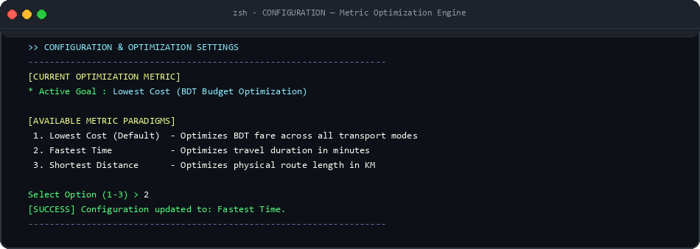
Figure 3.7: Optimization Metric Configuration Panel (Mac Terminal Theme)
Figure 3.7 illustrates the system configuration panel where the primary optimization objective can be dynamically switched between Lowest Cost, Fastest Time, and Shortest Distance.
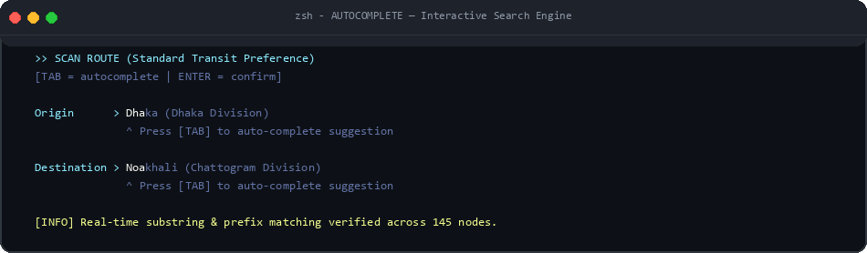
Figure 3.8: Interactive Real-Time Autocomplete Location Search (Mac Terminal Theme)
Figure 3.8 demonstrates the real-time autocomplete engine, displaying instant prefix matching and single-key [TAB] auto-completion across all 145 location nodes.

Chapter 4
Engineering Standards and Mapping
This chapter presents the engineering standards applied in the development of the system and provides a structured mapping of program outcomes and complex engineering problems. It also highlights the project's impact on society, environment, and sustainability, along with team contributions and problem-solving approaches.
4.1 Impact on Society, Environment and Sustainability
4.1.1 Impact on Life
The Route Planner enhances everyday transportation by providing efficient and reliable routes between different locations. It can help students reach university on time, commuters avoid unnecessary delays, and delivery services reduce travel time and fuel costs. By applying shortest-path algorithms, the system enables users to make smarter travel decisions, minimize transportation costs, and improve overall mobility. It is especially useful in real-world situations where multiple routes are available and choosing the most efficient one can save significant time and resources. Overall, it contributes to a faster, more efficient, and convenient transportation experience.
4.1.2 Impact on Society & Environment
Efficient route planning can play an important role in building a smarter and more sustainable transportation system. By helping people choose optimal routes, it can reduce traffic congestion, unnecessary fuel consumption, and travel time. This leads to lower vehicle emissions and helps minimize air pollution and environmental damage. It can also improve accessibility for students, commuters, emergency services, and delivery providers by making transportation more organized and efficient. Overall, it supports sustainable mobility, responsible resource use, and a cleaner, more efficient society.
4.1.3 Ethical Aspects
The system should ensure fairness, safety, privacy, and transparency when recommending routes. It should provide reliable route information without unfairly prioritizing certain users or locations. User data, such as travel history and location information, should be handled securely and only used when necessary. The system should also clearly communicate its route-selection criteria so users can understand and trust its recommendations. Additionally, it should consider accessibility and safety, ensuring that route suggestions do not unnecessarily expose users to unsafe or restricted areas. Overall, ethical route planning promotes responsible technology, user privacy, equal access, and safe decision-making.
4.1.4 Sustainability Plan
Long-term sustainability will be ensured through continuous improvement, reliable data management, and efficient algorithm optimization. Regular updates to road networks, traffic conditions, and route information will keep the system accurate and relevant. The system can also be expanded to support real-time traffic updates, public transportation, walking, and eco-friendly routes, making it useful for a wider range of users. Efficient algorithms and scalable system design will help maintain performance as the number of users and locations grows. Continuous testing, security improvements, and user feedback will further enhance reliability. Overall, the plan focuses on long-term efficiency, scalability, accuracy, and sustainable transportation.
4.2 Project Management and Team Work
Table 4.1: Project Management and Team Work Breakdown
Topic | Name
Topic Selection | Muhammad Tanjeem, Md Sabbir Hossain, Zishna Mahmud Khan, Chandan Acharjee Himel, Ayrin Alom Any
Requirement Analysis | Muhammad Tanjeem, Md Sabbir Hossain, Zishna Mahmud Khan, Chandan Acharjee Himel, Ayrin Alom Any
System Design | Muhammad Tanjeem
System Implementation | Muhammad Tanjeem
Test | Muhammad Tanjeem, Md Sabbir Hossain, Zishna Mahmud Khan, Chandan Acharjee Himel, Ayrin Alom Any
Report Writing | Muhammad Tanjeem,MD. Sabbir Hossain Shamim

4.3 Complex Engineering Problem
Mapping of Program Outcome
Table 4.2: Justification of Program Outcomes (POs)
PO' s | Justification
PO3 | This project demonstrates the ability to design and develop an efficient route planning solution for real-world transportation problems. The system models locations and roads as a graph and applies suitable algorithms such as shortest-path techniques to determine efficient routes. Different functional components, including route selection, distance calculation, and path visualization, are integrated into a structured system. The overall design focuses on providing accurate, efficient, and practical routing solutions.
PO5 | This project applies appropriate modern programming techniques and algorithmic approaches to solve route optimization problems. Graph representation, shortest-path algorithms, searching techniques, and complexity analysis are used to ensure efficient route calculation. These techniques were selected based on the problem requirements and performance considerations, allowing the system to provide reliable and scalable routing solutions for real-world transportation scenarios.
PO9 | This project reflects effective teamwork and individual contribution throughout its development. Team members were assigned specific responsibilities such as algorithm selection, system design, implementation, testing, and documentation. Regular communication and collaboration helped integrate different components of the Route Planner effectively. Teamwork also supported efficient problem-solving, debugging, and successful completion of the project within the given timeframe.
PO4 | This project demonstrates the ability to analyze and evaluate algorithmic solutions based on their efficiency and performance. Different routing approaches were considered and their time and space complexities were analyzed to select a suitable algorithm. Testing with different numbers of locations and routes helped evaluate the system's performance and identify opportunities for optimization.
PO10 | This project demonstrates effective technical communication and documentation throughout the development process. The team documented the problem statement, algorithmic approach, system design, implementation, testing results, and performance analysis in a clear and organized manner. Team members also communicated their individual contributions and project findings effectively, ensuring that the overall solution could be understood and presented professionally.

Complex Problem Solving
Table 4.3: Mapping with complex problem solving.
EP 1  Deptof  Knowledge | EP 2  Rangeof  Conflicting  Requirements | EP 3  Depthof  Analysis | EP 4  Familiarity  of Issues | EP 5  Extentof  Applicable  Codes | EP 6  Extent  Of Stakeholder  Involvement | EP 7  Inter-  dependence
Yes | Yes | Not Applicable | Not Applicable | Not Applicable | Not Applicable | Not Applicable
EP1: Our Route Planner falls under EP1: Depth of Knowledge, because it requires a strong understanding of algorithms, graph theory, and computational problem-solving techniques. We used graph-based representations to model locations and roads, along with shortest-path algorithms to determine efficient routes between destinations. The system also requires an understanding of time and space complexity to ensure that the selected algorithms perform efficiently. Thus, the application of these core algorithmic concepts demonstrates the required depth of engineering knowledge. The evidence for achieving EP1 is documented in Chapter 2, Requirement Analysis, Section 1.1, Overview of the Project.
EP 2: The Route Planner involves multiple possible approaches for solving the same routing problem. Different factors such as shortest distance, minimum travel time, route efficiency, and computational performance may lead to different route selections. Several algorithmic approaches can also be considered, but selecting the most appropriate one requires balancing accuracy, efficiency, scalability, and system requirements. We selected the suitable routing approach based on these factors to provide an efficient and practical solution. The evidence of this decision is documented in Chapter 2, Requirement Analysis, Section 1.1, Overview of the Project.
Engineering Activities
Table 4.4: Mapping with complex engineering activities.
EA 1  Range of  resources | EA 2  Level of  Interaction | EA 3  Innovation | EA 4  Consequences for  society and env | EA 5  Familiarity
Not Applicable | Not Applicable | Not Applicable | Not Applicable | Not Applicable

Chapter 5
Conclusion
This chapter provides a concise overview of the implemented route planning system, summarizing its core functionalities and overall performance. It also highlights the key limitations of the system and discusses potential areas for future improvement and enhancement.
Summary
BLACK PROTOCOL — Bangladesh Route Intelligence System is a multi-modal transit planning system designed to simplify and optimize inter-city travel across Bangladesh. It compares highway bus, intercity railway, and inland waterway/launch options using graph algorithms to help travelers make informed decisions about the most efficient and cost-effective routes.
Main Objective
The main objective of this system is to enable travelers to find the optimal route between any two locations in Bangladesh, considering cost, time, and distance trade-offs across multiple transport modes. It also aims to provide a budget optimization feature that identifies the absolute cheapest travel option and reduce the confusion of manually comparing different transport modes.
Key Features
The system includes several important features such as SCAN ROUTE (multi-modal comparison using Dijkstra's algorithm), DEEP SCAN (lowest cost budget optimizer), HIERARCHY DECODE (administrative tree structure of all 8 divisions), SYSTEM COMPLEXITY (Big-O time and space analysis), and SYSTEM CONFIGURATION (optimization metric selection). It also includes real-time autocomplete input with tab-completion for location search, color-coded ANSI terminal output, and a professional ASCII art banner.
The system is developed using important data structures such as adjacency lists for graph representation, structs for location and edge data, enums for transport type and metric classification, and arrays for distance/predecessor tracking in Dijkstra's algorithm.
Problem & Solution
In the traditional approach, travelers need to manually research multiple transport options, compare fares from different sources, and estimate travel times without systematic analysis. This process is time-consuming, error-prone, and often results in suboptimal choices.
This system solves these problems by modeling the entire Bangladesh transportation network as a weighted graph and applying Dijkstra's shortest path algorithm to find the optimal route for each transport mode independently. It then presents a structured comparison that allows travelers to make informed decisions instantly. The Deep Scan feature further simplifies budget travel planning by automatically identifying the cheapest option.
System Workflow
The system has one main user type: the traveler. First, the user selects an operation mode (SCAN ROUTE or DEEP SCAN). Then the user enters the origin and destination locations using the autocomplete input system. The system runs Dijkstra's algorithm for each applicable transport mode and displays the multi-modal comparison with route paths, distances, fares, and travel times. The user can then review the results and make an informed travel decision.
Technologies Used
The system is implemented using the C programming language (C11 standard). It uses data structures such as adjacency lists (array of edge lists), structs (Place, Edge, EList, Map, Route, Routes), and enums (TrType, Metric, LocLv). Terminal rendering uses ANSI VT100 escape codes for 256-color output and Windows Console API for compatibility. Compilation is performed with GCC (MSYS2 UCRT64 toolchain).
Advantages
This system offers several advantages, including fast algorithmic computation (Dijkstra runs in milliseconds for 145 nodes), accurate distance data calibrated to Google Maps and Bangladesh Railway, multi-modal transport comparison (bus vs train vs launch), budget optimization for cost-conscious travelers, and a professional terminal interface with autocomplete input.
Limitation
- Limited Accessibility (Local System Dependency): The system is restricted to the specific machine on which it is installed, making it inaccessible from external devices such as mobile phones or remote systems. Unlike web-based platforms, it does not support remote access.
- Absence of Real-Time Traffic & GPS: The system relies on embedded static road and rail network weights. Without live GPS telemetry, dynamic road blockages cannot be reflected in real time.
- Console-Based Interface: The system utilizes a text-based terminal console rather than an interactive graphical map layout.
Future Work
- Development of an Online/Web-Based Platform: Transforming the core engine into a web or mobile application with interactive geographical map visualization.
- Integration with Live Traffic & Booking APIs: Connecting to real-time traffic data feeds and ticket booking portals.
- Improvement of User Interface (GUI-Based System): Building a desktop or mobile graphical user interface with visual route pathing.

References
[1] Brian W. Kernighan and Dennis M. Ritchie. The C Programming Language. Prentice Hall, 1988.
Available: https://www.pearson.com/en-us/subject-catalog/p/c-programming-language/P200000000305
[2] Mark Allen Weiss. Data Structures and Algorithm Analysis in C. Pearson, 2014.
Available: https://www.pearson.com/en-us/subject-catalog/p/data-structures-and-algorithm- analysis-in-c/P200000003264
[3] Thomas H. Cormen, Charles E. Leiserson, Ronald L. Rivest, and Clifford Stein. Introduction to Algorithms. 3rd ed., MIT Press, 2009.
Available: https://mitpress.mit.edu/9780262033848/introduction-to-algorithms/
[4] E. W. Dijkstra. 'A Note on Two Problems in Connexion with Graphs.' Numerische Mathematik, vol. 1, no. 1, pp. 269–271, 1959.
Available: https://doi.org/10.1007/BF01386390
[5] Robert W. Floyd. 'Algorithm 97: Shortest Path.' Communications of the ACM, vol. 5, no. 6, p. 345, 1962.
Available: https://doi.org/10.1145/367766.368168
[6] Google Maps Platform Documentation and Distance Matrix API.
Available: https://developers.google.com/maps/documentation
[7] Bangladesh Railway Official Timetable, Fares and Distance Table.
Available: https://railway.gov.bd
[8] Bangladesh Road Transport Authority (BRTA) Inter-District Bus Fare Regulations.
Available: http://www.brta.gov.bd
[9] Bangladesh Inland Water Transport Authority (BIWTA) Launch Passenger Service Schedules.
Available: http://www.biwta.gov.bd
[10] TutorialsPoint. 'Data Structures Using C.'
Available: https://www.tutorialspoint.com
[11] OpenAI. ChatGPT (GPT-5.3).
Available: https://chat.openai.com
[12] Google. Gemini AI.
Available: https://gemini.google.com
[13] xAI. Grok AI.
Available: https://x.ai

